Reforesting the Glens
Scottish Charity No SC044472
Annual General Meeting: 21 Dec 2017

Bob Glen Chair, Secretary, Treasurer
Jill Glen
Joyce Maciver

Report by Chairman:
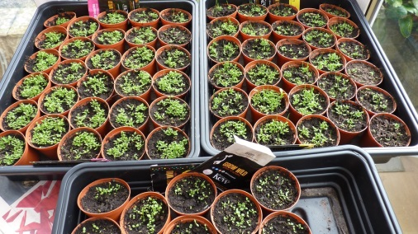
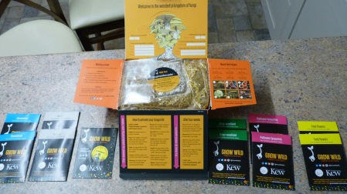
In March, I received 13 packets of wildflower seeds and a fungi kit from Kew Botanics Gardens. I started them at home, and successfully planted them out at The Knock
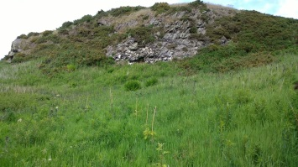

In April, I also planted 9 rowans.

In June, I planted 14 silver birches.

In September, I applied for another Woodland Trust tree pack, but was unsuccessful. Not a problem, as I still have several dozen saplings at the allotment for next year.

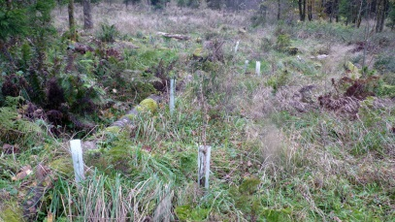
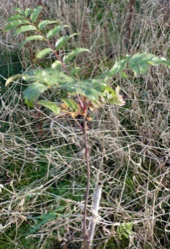
Planted 15 saplings at Broadwood October 28th, 2017, and checked previous plantings – all doing well.

Planted 12 silver birch at Knock Hill 29th October 2017 – wildflowers doing well. Local farmer advised me the site is susceptible to locals burning the gorse.
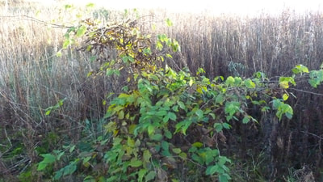

In November, good news at Kirk O'Shotts – trees are well established.
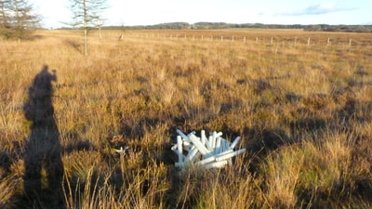

But bad news at Salsburgh West - all except 2 of my tree protectors had been removed again, for the umpteenth time. This time, they also removed the supporting canes and dispersed the protectors, so it was hard to find any surviving saplings (apart from 2 healthy holly, presumably not favoured by the deer). The site is regenerating from the commercial coniferous plantation, which is good, but I grieve for my beautiful wee oaks and rowans - unprotected, the deer would make short work of them - 4 years work lost, and 100 trees. I collected the tree protectors and removed them. I left with cold wet feet, and sadly decided I won't try here again.

I planted 8 alder at Salsburgh East, accompanied by 6 local kids, who promised they’d look after them!

Website has been kept up to date.

Treasurer’s report:

No income raised. All expenditure on materials and travel has been met by the Chairman.

Any other business: No changes to Trustees.

Signed:

Bob Glen ___________________________ Chair, Secretary, Treasurer

Jill Glen ___________________________

Joyce Maciver ___________________________

