Reforesting the Glens
Scottish Charity No SC044472
Annual General Meeting: 21 Dec 2018

Bob Glen Chair, Secretary, Treasurer
Jill Glen
Joyce Maciver

Report by Chairman:
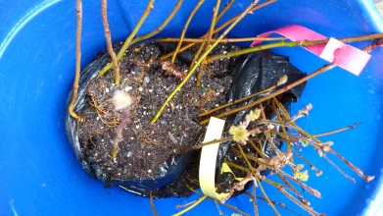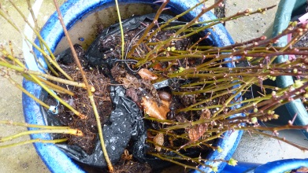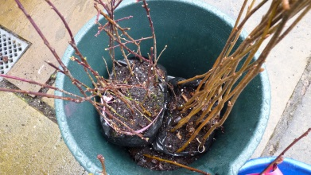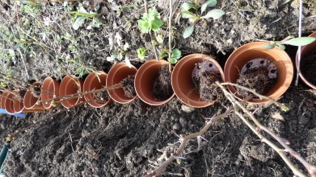

In April, I received another 115 young trees and planted out at my allotment. Wildlife pack: hawthorn, rowan, blackthorn, silver birch, hazel, and common oak

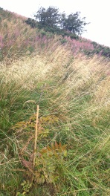
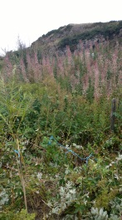
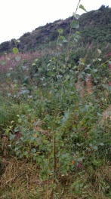
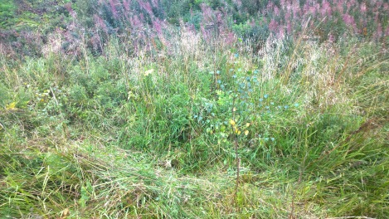
In August, I Cleared the undergrowth round the previous planting of silver birches at The Knock, and planted 10 rowan and willow trees.
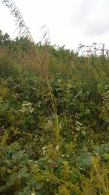
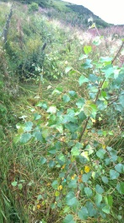

I also checked previous plantings at Broadwood, Cumbernauld - all look OK
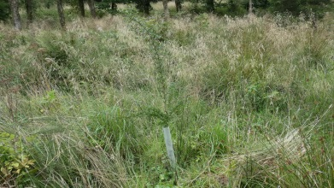
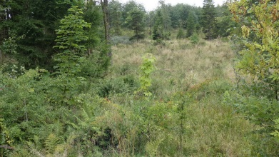
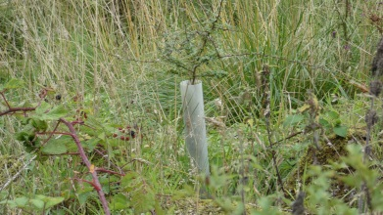
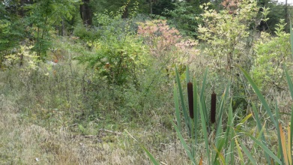

In November, I had a surplus stock of 300 tree protectors and canes which I have donated to Friends of Cammo (value £180). I also booked a week to plant trees with Trees for Life in Glen Affric from 6 to 13 April 2019 (£185)

I received a double Woodland Trust tree pack of 230 saplings, and planted them out at my allotment.

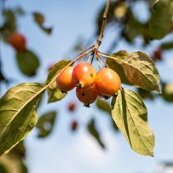
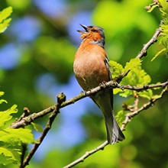
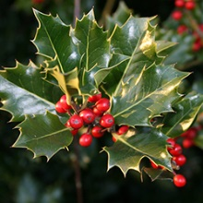

Website has been kept up to date.

Treasurer’s report:

No income raised. All expenditure on materials and travel has been met by the Chairman.

Any other business: No changes to Trustees.

Signed:

Bob Glen ___________________________ Chair, Secretary, Treasurer

Jill Glen ___________________________

Joyce Maciver ___________________________

