Reforesting the Glens
Scottish Charity No SC044472
Annual General Meeting: 31 Dec 2019

Bob Glen Chair, Secretary, Treasurer
Jill Glen
Joyce MacIver

Report by Chairman:

- In April, I checked my young trees in Salsburgh and they are now 10 feet high!

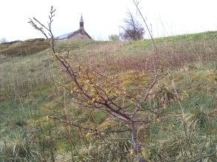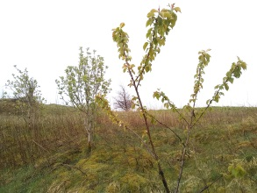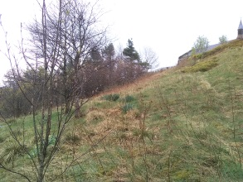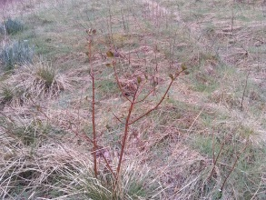

- Also in April, I spent a week with Trees for Life in Glen Affric, planting trees, clearing non-native species and surveying tree re-generation (£150).

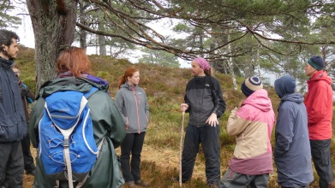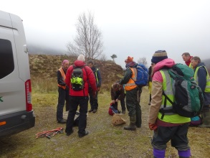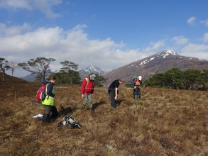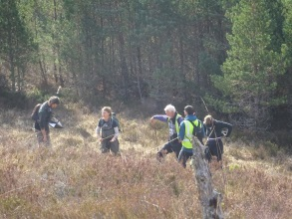
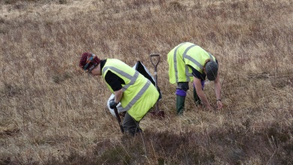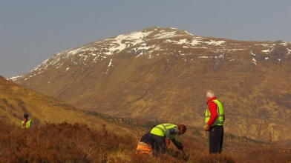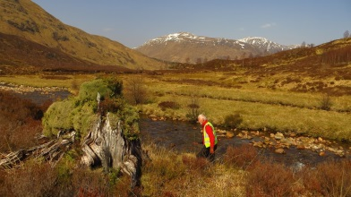
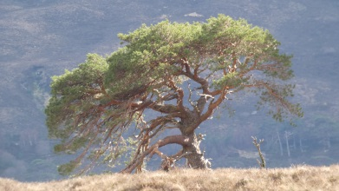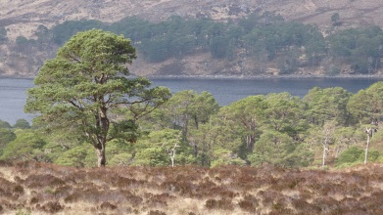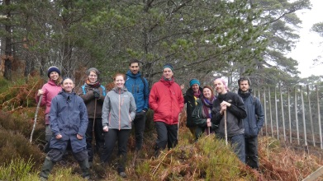

- In May, dozens of wee trees were shooting up at my allotment.

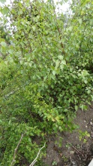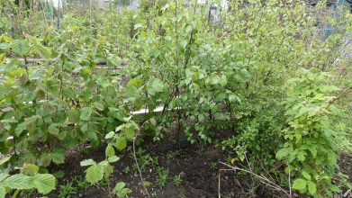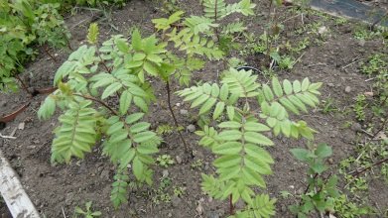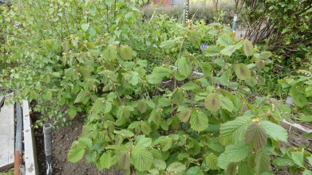

- In June, I was given permission for a new tree planting site at Hillend Country Park on the north eastern slopes of the Pentlands by Victor Partridge, Natural Heritage Officer, Forestry and Natural Heritage, The City of Edinburgh Council. I’ve dozens of well-established trees ready to plant out.

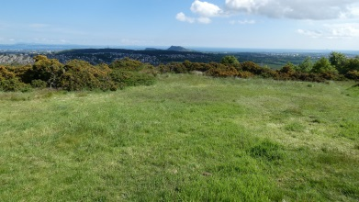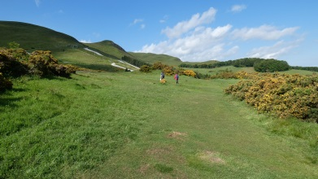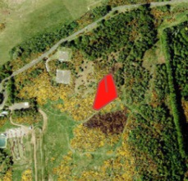

- In July, I planted a wee rowan in memory of my Dad at The Knock.

- In September, I planted about 40 rowan, hawthorn, hazel and blackthorn at Hillend Country Park.

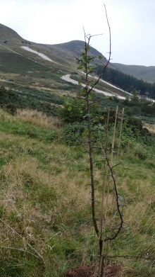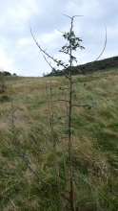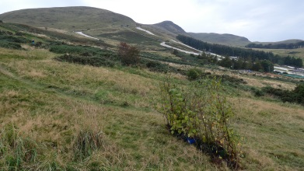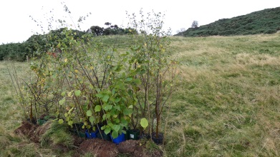

- In October, I received news from the Woodland Trust that I would receive a Wildlife pack in March with 115 hawthorn, rowan, blackthorn, silver birch, hazel and common oak saplings – to establish food and shelter for wildlife and create a living legacy for future generations.
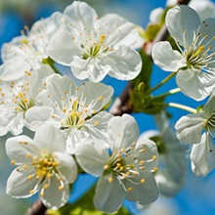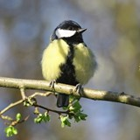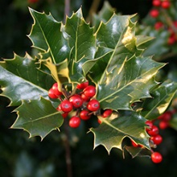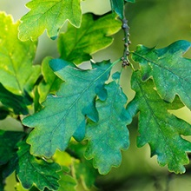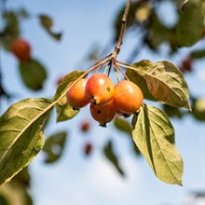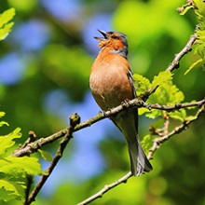

- In November, I provided 15 willow trees to Pentland Hills Regional Park for planting at Threipmuir Reservoir with 200 other willows. They have been establishing themselves at my allotment for the last 4 or 5 years, have well established roots, and are nearly 5 feet tall, so should quickly establish themselves. It will definitely enhance a beautiful loch, and I look forward to seeing them grow.

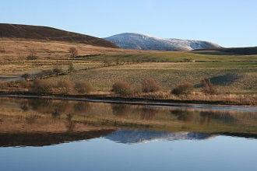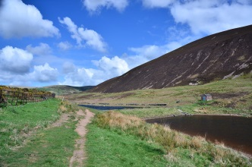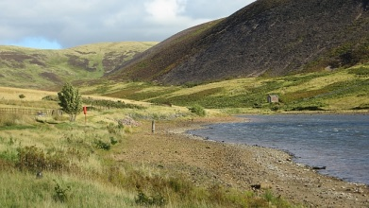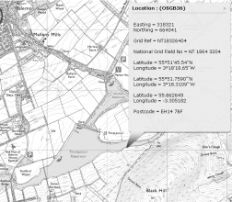

In December, I re-potted 24 holly, hawthorn and hazel which are about 5 years old, well-established and overdue for re-potting, then planted them out at Hillend Country Park.

I have booked another week’s volunteering at Trees for Life at Dundreggan for March 2020 (£195).

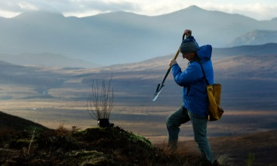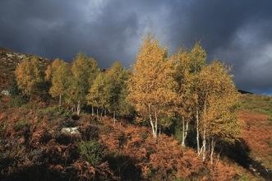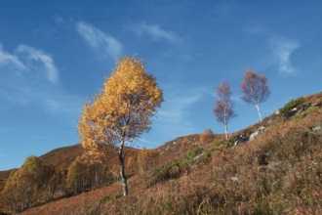

- My Website has been updated with my activities, and also with articles on reforesting Scotland.

Treasurer’s report:

No income raised. All expenditure on volunteering, materials and travel has been met by the Chairman.

Any other business: No changes to Trustees.

Signed:

Bob Glen ___________________________ Chair, Secretary, Treasurer

Jill Glen ___________________________

Joyce MacIver ___________________________

