Mindless destruction of trees at Hillend Country Park
I have been planting trees in a small way for some 16 years in various locations all over Scotland, and have spent 2 weeks volunteering with Trees For Life at Glen Affric and Dundreggan. I established a charity Reforesting the Glens in 2013 (Scottish Charity No SC044472) and lodge annual reports on my activity.
Permission to plant in designated areas in Hillend Country Park was granted on 5 June 2019 by Victor Partridge, Natural Heritage Officer, Pentland Hills Regional Park, who is responsible for the Country Park on behalf of Midlothian Council.
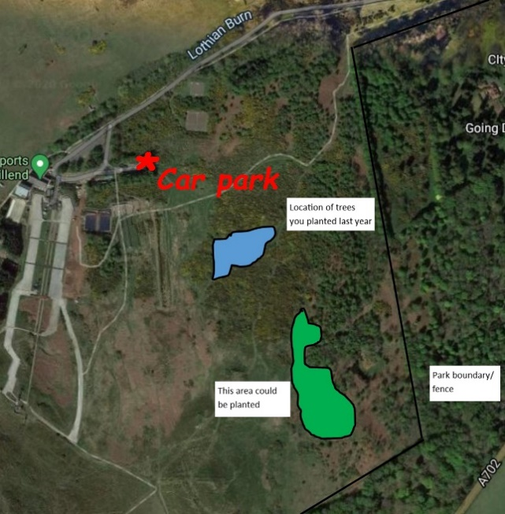
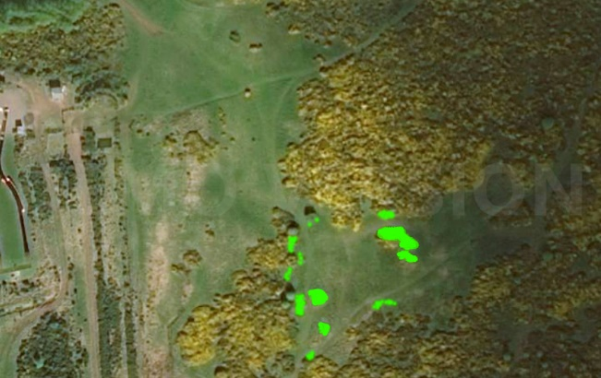
Gorse is increasingly taking over at the park, so patches were removed to free up established trees, create a firebreak and increase space for planting.

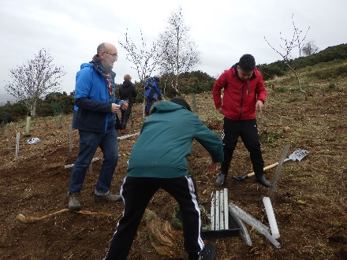
I had assistance from friends and local Scout groups.
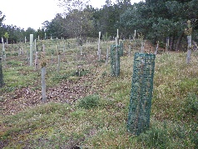
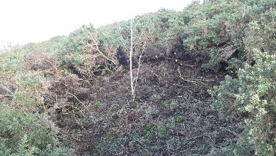
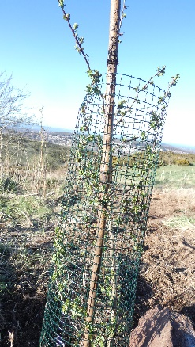
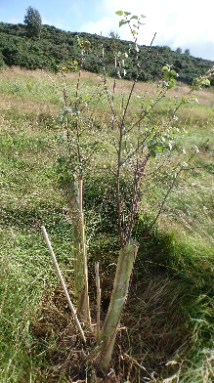
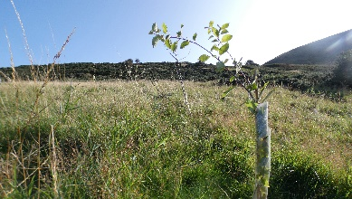
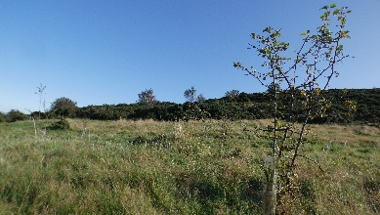
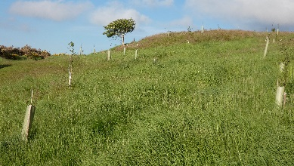
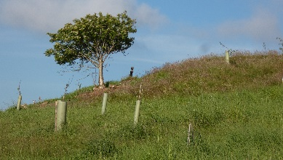
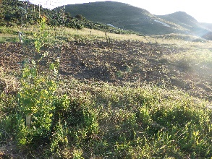
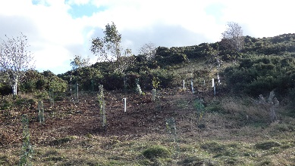
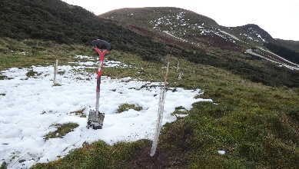
Plugs of hardy native species with known provenance were initially planted out at my allotment for 2 – 4 years: rowan, oak, silver birch, hazel, blackthorn, crab apple, downy birch, hawthorn, holly, bird cherry, dog rose, plus 10 Scots Pine and 6 juniper. I planted a total of more than 830 trees in Hillend Country Park in winter 2019 (70), 2020(100), and 2021(660). Care was taken to plant as though the woodland was natural. Weeded, watered and protected from deer and rabbits.
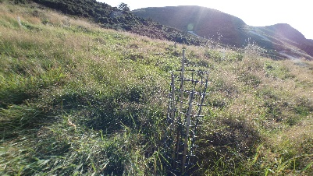

Winter 2021 – 2022: I was tree planting at Lauriston Farm, so had little time to visit Hillend.

16 April 2022: Nearly 200 trees were uprooted or cut down. This is not kids vandalism - it was premeditated, or they wouldn't have brought the tools to cut down the trees. Who in this day and age wants to see fewer trees? Years of work gone in a few hours. I reported this to Victor Partridge, but nothing came of it. I reported it to Dennis Smith, Secretary of Friends of the Pentlands, who had no knowledge or clues as to who it might have been.
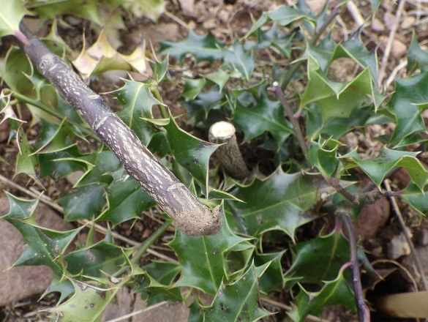
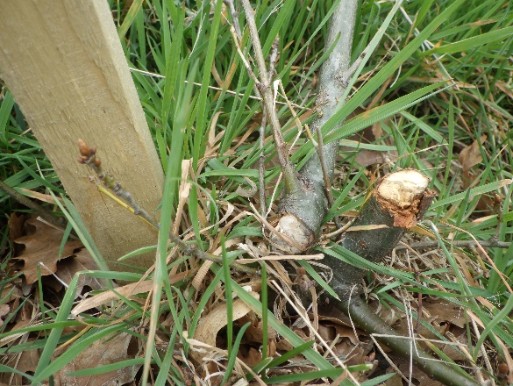

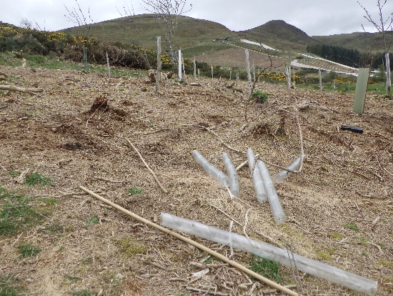
Plastic tree protectors and stakes strewn around the hillside.
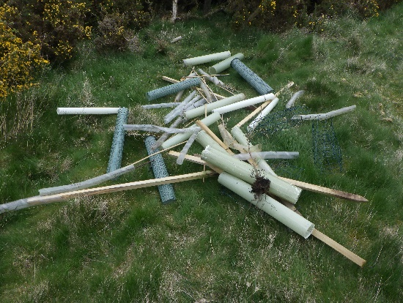
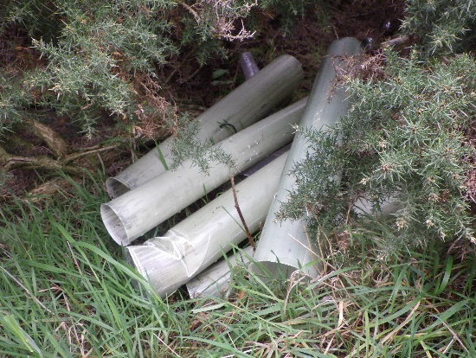
1 November 2022: It took me 6 months to re-visit my wee trees at Hillend Country Park, in the hope that some of them might have survived being cut to the bone.

The answer to that was no, there were no survivors of the 200 trees cut down in the spring - destroying 2 full seasons of planting (and 3 or 4 years nurturing at the allotment prior to that).

Even worse, the culprits have returned and cut down a further 300 older trees, despite them being secured with 5 foot stakes. And 300 saplings that were planted further up the hill in 2021. That's destroyed 3 seasons of planting (and 3 or 4 years nurturing at the allotment prior to that). Some trees were nearly 6 feet high.
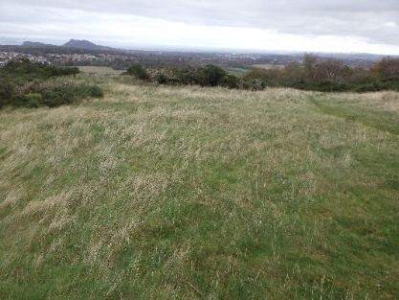
Again, they've just left the stakes and tree protectors scattered all over. So, when I might have expected to see a wee wood forming, it's bare hillside again - and the gorse that I cut is making a comeback - it'll soon take over again.

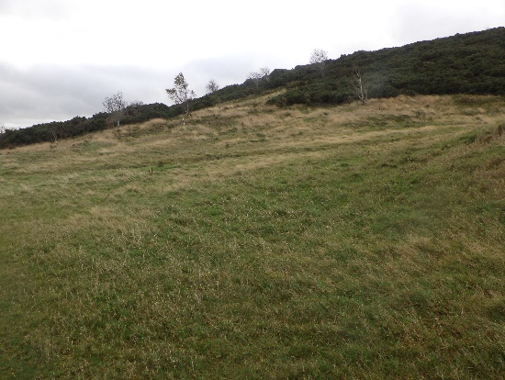
All that work for nothing, and a betrayal of friends and local Scout groups who helped to make it happen.
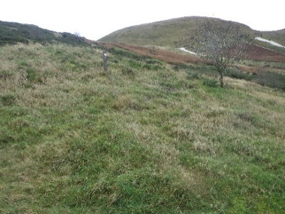
Who would do such a thing, when we are facing a climate emergency?

Dogwalkers regularly use the area, and have been complimentary and supportive of tree planting. None that I spoke to had seen anybody engaged in cutting down the trees.

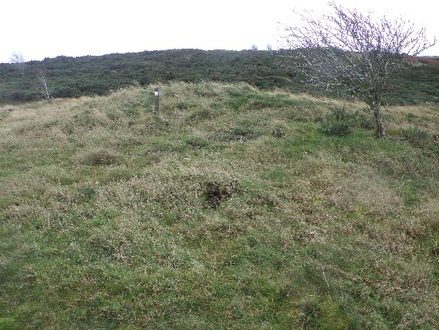
I spoke to a worker with the Water Board, who are working in the lower slopes at Hillend Country Park, who said they had no interest in trees planted further up the hill, but were being pressured by developers to vacate the lower car park in order to allow further work on the Country Park.
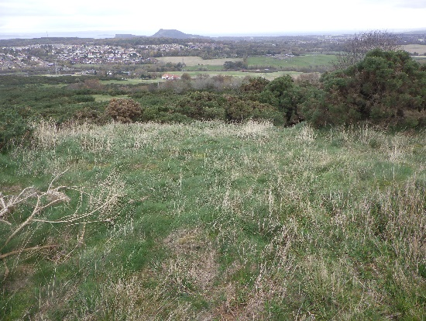
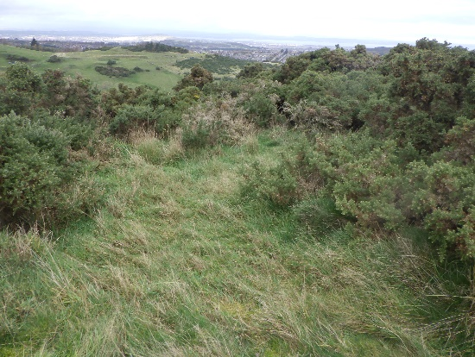

Midlothian councillors approved a final business case for Destination Hillend in August 2021, and work has now started. Midlothian Snowsports Centre will be redeveloped into a major multi-activity leisure, retail and tourist attraction offering: a new zip line, a new Alpine Coaster, a new glamping complex, new fun slope (completed already), upgraded and modern facilities with enhanced snowsports storage, a new café with full kitchen and ‘back of house’ provision, fine dining, outdoor seating, a retail unit, increased car parking capacity (425 spaces), an improved public road junction, a new soft play area, a new high rope activity, enhanced and flexible children’s party rooms, and a new function suite.

The trees were destroyed in the Country Park, not the Snowsports Centre. No discussion has been held with (or permission sought from) the Natural Heritage Officer, Pentland Hills Regional Park - who is responsible for the management of Hillend Country Park, designated the area and gave permission for me to plant.

I reported the destruction to James Kinch at Midlothian Council, and Mike Ronald at Midlothian Snowsports Centre, but again, no action was forthcoming. Reported to Police Scotland on 27 January 2023 (Incident PS-20230127-0040).

The fact that neither Pentland Hills Regional Park nor Midlothian County Council were aware of any damage over a period of months (until I notified them) shows little regard for their responsibilities.

The story of my tree planting (not only at Hillend) can be found on a blog at https://reforesting-the-glens.weebly.com/blog/another-bout-of-mindless-destruction-at-hillend-country-park.

